THE MASTER’S MESSAGE
Brethren,
I want to personally share an update regarding my recent absence. I experienced a heart attack that required immediate medical attention, followed by a successful quadruple bypass surgery. While this was unexpected, I am grateful to report that I am on the road to recovery and in good spirits.
My focus right now is on healing and regaining my strength. I will return to the Lodge as soon as I am physically able to do so. Until that time, please know that I remain actively engaged and committed to my duties as Worshipful Master, continuing to guide our Lodge as best I can during this period.
I want to extend my sincere gratitude to our Senior Warden, Brother Brian Moore, who has graciously stepped up to preside over our meetings in my absence. His leadership and willingness to serve during this time of need are a true reflection of the strength of our Brotherhood.
Thank you all for your support, prayers, and understanding. It means more than words can express. I look forward to being back among you soon.
Fraternally yours.
Scott Foster
Worshipful Master
Awaiting EA Degree
Arun Gupta

Awaiting Fellowcraft Degree
Daniel P Miller
Efrain Calderon Jr.
Curtis G. Nesmith
Edward Dilegge
David Milov
Ariel Coss
John J. Losito
Dellshone McKenzie
Jacek Kwiatkowski

Awaiting Master Mason Degree
Jose Montes



LIVINGSTON LODGE NO. 11
MASONIC BIRTHDAYS
April 2026
Come and Enjoy Cake and a special gift

Russell Costello  Randolph Henderson  Alen Parke  Charles Hug | Ronald Parke  Michael Sciame  Roy Winfield  David Martin

To Register for Grand View
Click on "Member Registration" in the login screen.
Here is a quick link to that registration page. https://nj.grandview.systems/membership_registration

APRIL 2026 COMMUNICATIONS

Wednesday, April 1___ 7:30PM
Meeting: OV Practice

Wednesday, April 8 7:30PM
Trustee Meeting

Wednesday, April 15 7:30PM
Meeting: OV Practice

Wednesday, April 22 7:30PM
Craftsmen’s Club Meeting

8th District Events

DLI, Copestone-Ophir, April 23, 2026

2026 Dues is now due
PLEASE mail your check to the lodge or Secretary
Pay with Zelle via
Secretary@livingstonlodge11.org

RW Ira Drucks – Secretary
201-207-6300
64 Oakwood Avenue
Livingston, NJ 07039

REMEMBER OUR SERVICE MEN AND WOMEN FIGHTING FOR OUR FREEDOM.

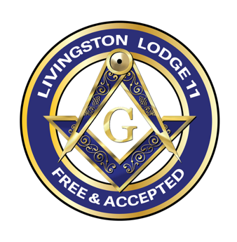
APRIL 2026
LIVINGSTON LODGE #11
Celebrating 216 years of Masonic Brotherhood
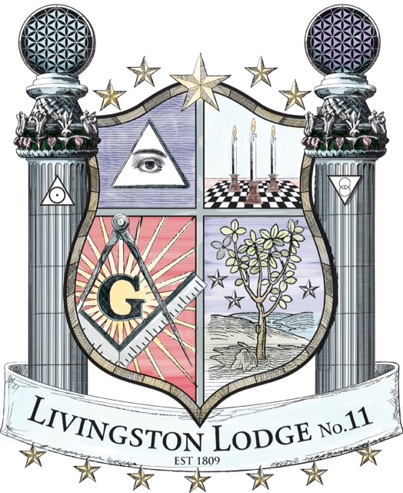
MASONIC LODGE
19 Burnet Street
Livingston, NJ 07039-5401
Telephone: (973) 994-4619
Meeting nights:
First and Third Wednesday
7:30 P.M.
Livingston Craftsmen’s Club meets 4th Wednesday of every month

LODGE WEBSITE
Livingstonlodge11.org
Lodge E-mail Address
Secretary@livingstonlodge11.org

LIVING PAST MASTERS

Martin L. Solomon 1964  Abraham Suckno 1965  Edward E. Pack 1968/06  Richard H. Kunz 1972  Richard Mondacci, Sr.1972/93  Charles Schuman 1973  RW Graham MacFarlane 1975  Robert R. Everton 1976  Fred D. Morrison 1976  RW Arnold Lange 7/85/86/87  Barry J. Vogel 1977  MW John S. Ryan 1990  John Collins. 1990  Jack Moss 1992  Alvin S. Solomon 1995  W. Robert George 1996  Gene Jannotti 1996//97 | Richard J. Ventola 1989  RW Ira P. Drucks99/00/03/04/05  Richard Mondacci, Jr. 2002/16  Steven Vance 2003  Peter X. Lee 2007  RW Guy Notte 2010  Russell W. Henderson 2012  RW Joseph T. Carney 2014  Jason F. Resendes 2015  Randolph Henderson 2017  RW Brandon W. McCune 2018  Richard j Barone 2019  Michael R Sciame 2020/21  Philip Shetsen 2022  Robert Freda 2023  Richard Biggs III 2024  Scott Foster 2025/26
Members Who Served as Masters of Other Masonic Lodges
Joseph R. Conway, PGM (KY)
Michael A. Moss
Richard J. Barone
Robert A. Freda
Vincent Brannon

Distinguished Brother
Sanford R. Drucks
Jay Schwartzapfel
Mark Jacques

LIVINGSTON CRAFTSMEN’S CLUB
Prakash Khaitan - President
973-568-0061
Sal Querques – Vice President
973-464-3693
Douglas McKay – Secretary
973-632-3888
Ira Drucks PGC - Treasurer
201-207-6300

TRUSTEES
Jack Ackerman (Virginia)…….…..1yr 973-296-2997
John Marcontonio (Alicia)………..1yr 973-736-8889
Jay Schwartzapfel (Laura)…….….3 yr. 551-404-5151
Prakash Khaitan…………………..2 yr 973-568-0061
Mark Jacques (Patricia)………......2 yr 973-650-0629

OFFICERS FOR 2026

Scott Foster (Sophia) Master
29 Amelia Ave
Livingston, NJ 07039
973-462-8436
Email: Livingston11WM@gmail.com

Brian R. Moore Senior Warden

Salvator Querques Junior Warden
26 Rosney Terrace
West Orange, NJ 07052
973-464-3693
Email: sq7766@gmail.com

Richard J. Ventola, PM | Treasurer
376 Alps Road
Wayne, NJ 07470
201-452-0539
Email: rventola@yahoo.com

Ira P. Drucks, GC (Lenore) | Secretary
64 Oakwood Avenue
Livingston, NJ 07039
201-207-6300 (Lenore)
E-mail: Secretary@livingstonlodge11.org

Angelo Querques……………………...…………………….Chaplain
973-222-7335
Javier Solis………. .….....…...….…………..…...…..Senior Deacon
973-567-5553
Kenneth Gibbons..…...…...……..….……..………...…Junior Deacon
973-902-9011
Javier J. Fernandez...…...….………….……Sr. Master of Ceremonies
973-787-6301
Prakash Khaitan…………..……………...…Jr. Master of Ceremonies
973-568-0061
Benjamin R. Demario……………..…………………..Senior Stewart
973-951-4966
John Marcantonio...….…………..…………..……….Junior Steward
973-736-8889
Mark Jacques…………….………………………….………..Marshal
973-650-0629
Jay H. Schwartzapfel.…..…...……………………………...Historian
551-404-5151
David M. Martin........................……………………………..Organist
201-317-3728
David (Jack) Ackerman………………………………...……....Tyler
973-296-2997
Angelo Querques…….……….….………..….……….…Proxy to GL
973-464-3693

COMMITTEES FOR 2026

SICK AND SHUT-INS
Jay Schwartzapfel 551-404-5151
Guy Notte, PDRI 973-919-1176

MENTORING COMMITTEE
Javier J. Fernandez 973-787-6301
Sal Querques 973-464-3693
Brian Moore 973-965-7742
FUNDRAISER COMMITTEE
Prakash Khaitan 973-568-0061
Scott Foster, WM 973-462-8436
CHARITY & COMMUNITY PROJECTS
Ira Drucks PGC 201-207-6300
Mark Jacques 973-650-0629
Jack Ackerman 973-296-2997
EVENTS COMMITTEE
Sal Querques 973-464-3693
Mark Jacques 973-650-0629

FINANCE AND AUDIT
Kenneth Gibbons 973-902-9011
Philip Shetsen, PM 973-953-1700
Prakash Khaitan 973-568-0061

JACOB FRITTS RELIEF FUND
Richard Biggs III, PM 201-895-1547
Brian Moore 973-965-7742

WILLIAM AVERY YORK SCHOLARSHIP FUND

Gene Jannotti, PM 908-301-1123

John S. Ryan, PGM 908-813-8511

HOSPITALITY/REFRESHMENTS
Scott Foster, WM 973-462-8436
Prakash Khaitan 973-568-0061
MUSEUM/LIBRARY COMMITTEE
Jay Schwartzapfel,DB 551-404-5151
Mark Jacques 973-650-0629

FUNERAL ORATOR
Brandon W. McCune, DDGM 973-946-6860
Guy F Notte PDRI 973-919-1176
Joseph T. Carney, RW 973-651-2745
CONSTITUTION AND BYLAWS
Ira Drucks, PGC 201-207-6300
Guy Notte, PDRI 973-919-1176
COMMUNICATIONS COMMITTEE
Scott Foster, WM 973-462-8436
FACILITIES MANAGEMENT
Mark Jacques 973-650-0629
Sal Querques 973-464-3693
Brent Yeomans 973-632-3482
BAR COMMITTEE
John M. Marcantonio 973-736-8889
David J. Ackerman 973-296-2997
Ira Drucks, PGC 201-207-6300



GRAND MASTER
STATE OF NEW JERSEY
MW Omar S. Morris
100 Barrack Street
Trenton, NJ 08608
Cell: 201-362-3982
Email: nigm2024@gmail.com

DISTRICT DEPUTY GRAND MASTER
8th MasonicDistrict
RW Larry Alcime
9 Wedgewood Drive
West Orange, NJ 07052
Cell: 646-824-2092
Email: lalcime148@gmail.com

DISTRICT RITUAL INSTRUCTOR
8th MasonicDistrict
RW Javier E. Felicano
Cell: 347-559-2178
Email: Javier.e.felicano@gmail.com

8th DISTRICT BLOOD CHAIRMAN
R.W. Joel Finnerty
914-329-9831
JoelFinerty@gmail.com

MASONIC OUTREACH HOTLINE
800-792-8690
If tragedy hits or help is needed, call this number. Help, even legal assistance, can often be provided..

