Union Lodge #19
Free & Accepted Masons
Constituted April 9, 1850

November & December 2025

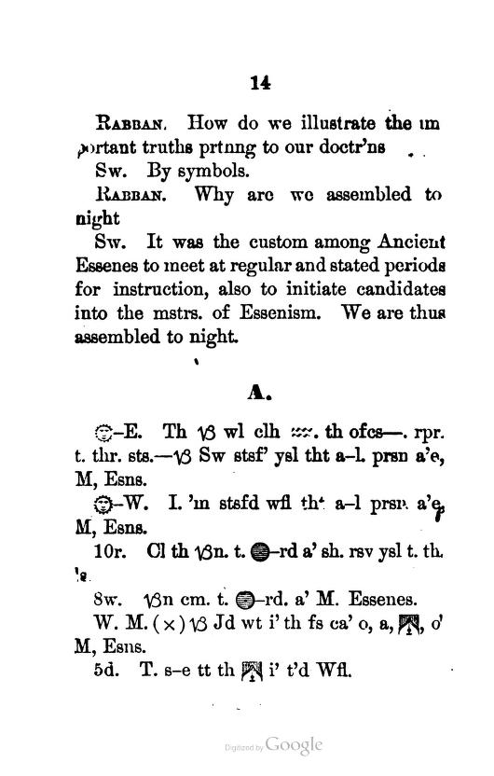

Regular Communications
First and Third Mondays 7:30 PM
Masonic Temple
60 Cedar Avenue
North Brunswick, NJ 08902
732-595-7850
unionlodge19@gmail.com
https://www.unionlodge-19.com
2025 Officers
Worshipful Master RW Roy Kowalski PJGD
(609) 610-2720
roykowalski13@verizon.net
Senior Warden WB Eric D. Wolff
(732) 245-9042
Eric.wolff1@gmail.com
Junior Warden WB Arthur H. Campbell, III
(848) 459-8498
ahciii@yahoo.com
Treasurer RW David Littman
(908) 754-7575
DBL1557@aol.com

Secretary RW Raymond P. Helge
732-513-2601
rp_helge1776@yahoo.com
Chaplain WB Larry Hriczak
(732)-299-9538
Senior Deacon WB Alfred J. Rodriguez
(732) 239-3482
Junior Deacon DB Frank P. Moschella, Jr
(862) 222-0235
Sr. M. of Ceremonies Br. Kent W. Simpson
(732) 768-7122
Jr. M. of Ceremonies Br. Pedro A. Duaso
(732) 619-6447
Senior Steward Br. Gregory P. Dohn
(732) 735-6506
Junior Steward Br. Dylan J. Moynihan
(757) 319-8024
Marshall DB Arthur Schneier
(732) 208-3297
Tyler DB John Dougherty
(732) 797-0772
Historian RW Bernhard W. Hoff
(848) 250-1350
Proxy to Grand Lodge RW David Littman
(908) 754-7575

Official Contacts
Grand Master of Masons
M.W. J. Eugene Margroff
100 Barrack St
Trenton, NJ 08608
cell 201 362 3982
Email: njgm2024@gmail.com
District Deputy Grand Master
R.W. John M. Sardis
732-763-0092
jmsardis@gmail.com
District Ritual Instructor
R.W. Robert N. Gaydosh
908-705-1055
rgaydosh@Verizon.net
Standing Committees
Sickness and Distress
RW. Ray Helge, PDDGM
WB Eric Wolff
Finance and Budget
RW. Bernhard W. Hoff, PGH
RW. David B. Littman, PGC
Blood Bank
RW. Roy Kowalski, PJGD
WB Eric Wolff
By-Laws
RW. David B. Littman, PGC
RW. Raymond P. Helge, PDDGM
Membership
WB Arthur H. Campbell III
RW. Roy Kowalski, PJGD
Fundraising
RW. Roy Kowalski, PJGD
WB Arthur H. Campbell III
Audit
RW. Bernhard W. Hoff, PGH
WB Larry Hriczak
Trustees of Union Lodge
BR Arthur M Schneier, DB | 2025
Bro. John Dougherty | 2026
WB Alfred J. Rodriguez  WB Larry Hriczak | 2027  2028
BR Frank Moschella, Sr | 2029

Active Past Masters

WB Dean M Shoemaker | 1969
RW John Mavrakis, PSGS | 1971/98
WB Jerome G Kadesh | 1971
RW David B Littman PGC | 1975
RW George Petrantonakis PGC | 1982/92/99
RW Roy Kowalski, PJGD | 2000/24
WB Maxim G Marcille, Jr | 2001/04
RW Bernhard W Hoff PGH | 2004/08/17
WB Leroy Schneider | 2006
RW Gary W Filson, PGC 33° | 2007/16
WB Larry C Hriczak | 2008/19
WB Eric D Wolff | 2009
WB David Philips | 2012
WB George S Valenta III | 2013/14
WB Scott Linde | 2015
RW Raymond Helge, PDDGM | 2013/22
WB Alex Kolbasowski | 2012/14
WB Alfred J Rodriguez | 2016/20/21
WB Michael J Manzella | 2017
WB Russ Shirley | 2018
RW John M. Sardis, DRI  WB Arthur H. Campbell III | 2017/20  2023

Grand Lodge Mission

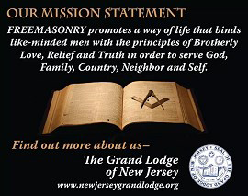
Designs Upon the Tressleboard
Lodge Dates
November:
3rd Mon Regular Communication Dinner 6:30pm
(per by-laws: present and meeting 7:30pm
Approve 2026 budget and Set 2026 lodge dues.)

10th Mon Ritual rehearsal & planing meeting 7:00 pm

15th Mon Regular Communication Dinner 6:30pm
meeting 7:30pm
13th Thur Fund raiser at Stumpy’s Hatchet House in P’ton.
This is main fundraiser of year. 6:00 – 9:00pm
Flyer attached to email distrib. of this T.B.

16th Sun Statewide MM degree @ Trenton Temple.
Union #19 plans to have two candidates.
RSVP with Sec’y Helge 9:00 open, 11:30 lunch

17th Mon Regular Communication Dinner 6:30pm
Nomination of 2026 officers. meeting 7:30pm

24th Mon Ritual Rehearsal 7:00 pm

December:
1st Mon Annual Communication Dinner 6:30pm
Elections, Lodges of sorrow C&O meeting 7:30pm
Memorial Service.

15th Mon Open Installation of Officers Social 5:00pm
Please RSVP with Sec’y Helge Dinner 6:00pm
To insure count for dinner. Inst’ln. 7:00pm

Other Official District Dates

November:
20th Thur District Lodge of Instruction 7:00 pm
Qualification Teams must attend.
Milltown Palestine #294

January:
10th Sat 12th Dist. Beefsteak Fundraiser @ Philo#243

12th District Installations:
Fri 5th St. Stephens#63, 7pm off site dinner to follow
Sat 6th Raritan Val #46, 4pm
Tue 9th Philo #243, dinner 6:30, Meeting 7:30, Inst. 8:00pm
Sat 13th Princeton #38, 3:30 pm
Sun 14th Milltown Palestine #294
Mon 15th Union #19 (see above)

Awaiting MM Degree:
Bro. FC Yu-Chuan “Archuan” Hu
Bro. FC Thiago Cardoso Carvalho
Bro. FC Obiora John Okagbue
Bro. FC Jordan James Coe

Historical Light
The cover art for this Trestleboard is a sample page from a ritual cypher that uses an entirely different set of symbols from what we use in NJ today.

There were two main cypher systems in common use in the US starting in the 1870’s. The cypher system we use was originally the system used in a series titled King Solomon and his Followers, published by Allen Publishing in NY, later acquired by McCoy’s. This page is from the competing Ecce Orienti cypher (Latin for Look to the East). In order to misdirect cowans, the book pretended to be a ritual of a fictitious Modern Order of Essenes, not masons.

The first 14 pages of the book contained a supposed history of that group. Finally in the middle of page 14 the actual masonic opening ceremony begins. This is not a NJ opening, but close enough that you can get the idea. My attempted translation follows:

WM. The brethren will be clothed and the officers repair to their stations. Brother SW satisfy yourself that all present are Master Essenes.
SW. I am satisfied worshipful that all present are Master Essenes.
WM. Call the brethren to order as such (rsv?) yourself that they are.
SW. Brethren come to order as Master Essenes (probably stand giving dg. & sn. & hold sn. of fidelity)
W.M. (X means rap to seat lodge) Brother JD, what is the first care of a lodge of Master Essenes?
JD. To see that the lodge is tyled Worshipful.

At first this cypher seems quite cumbersome to use, but only because we are used to something different. This standing to order as masons during opening is typical of English lodges, so it is no surprise that it is also done somewhere in US lodges as well.

Ben Hoff, Past Grand Historian
Grand Lodge Dates
Grand Lodge Annual Communication
November 5th & 6th @ Trop. In A.C.
Hospitality rooms open 4th !
See G.L. e-mails & website for details.
There are many other Grand Lodge Events, Grand Lodge Officer (future GMs Teams) Events, and Lodge Events that are in the Grand Lodge Electronic Newsletter.
Also at Union Lodge Building:
NJ Lodge of Research #1786 – Sat. Dec. 13th
Coffee & donuts 8:30am, meeting 9:00 am

Scott Chapter #4 RAM – Friday Nov. 14th
6:30 dinner, 7:30 meeting.

Scott Council #1 RSM – Friday Dec. 12th
6:30 dinner, 7:30 meeting.

Lodges of 12th Masonic District:
Union Lodge #19
60 Cedar Ave, North Brunswick NJ
1st and 3rd Monday, except July & August
Princeton Lodge # 38
345 River Road, Princeton NJ
2nd & 4th Monday, except July & August
Raritan Valley Lodge #46
14 No. Doughty Ave. Somerville, NJ
1st Wednesday, except July & August
St. Stephens Lodge #63
124 No. Broadway St., South Amboy, NJ
3rd Friday, year round
Philo Lodge #243
120 Old Bridge Turnpike, South River, NJ
2nd & 4th Tuesday, except July & August
Milltown Palestine Lodge #294
30 No. Main St., Milltown, NJ
1st & 3rd Tuesday, except July & August

From The East

Brethren,
I would like to thank you for giving me the honor and privilege to serve you as your Worshipful Master for the past 2 years.
I want to thank all of the Brothers and Officers who assisted and helped make the 2 years very successful for Union Lodge.
We have a very strong team of dedicated Brothers that work tirelessly to keep Union Lodge moving forward.
When I was on vacation in Italy this past summer I visited a Lodge/ Museum. The young Brother working there, about 80 years old, asked if I was active in my Lodge, I replied yes, I’m currently the Master, it’s my 3rd time.
He replied, that’s all, 7 times for in 3 different Lodges. He gave me a different perspective.. who knows what the future holds.
I wish WB Wolff and his team the very best in the coming year.
A young man, eager to satisfy his curiosity approached an old man, almost ninety, tall and erect, with a withered face and sunken eyes, in which there was still a gleam of Light. The young man looked at the Square and Compass above the Temple entrance and asked “I say old man what do you people do here. What is it you have to offer?” The old man answered, “Whatever Good you may desire, my son.” The youth hesitated a moment and replied “I desire nothing for myself, but wish for greater understanding tolerance, peace, and harmony among mankind.” The old man gazed pensively at the youth and said “Ah, we do not sell nor offer fruit here. In our Sacred Retreat we freely dispense seeds to all who would but accept them. We will help install in all the Seed of faith, the Seed of hope, the Seed of virtue and morality. It will become your Charge to go out into the world and sow those seeds, that others may see the emulate.”
My Brother, as you stand before us to all appearances an upright man and a Mason, I give it to you strictly in Charge ever to act, walk, and conduct yourself as such before God and man.
God Bless you all,
Roy Kowalski

